**Project Scope Document**

on

**Intelligent Customer Care HelpDesk With Smart Document Understanding**

# Project Summary: -

The typical customer care chatbot can answer simple questions, such as store locations and hours, directions, and maybe even making appointments. When a question falls outside of the scope of the pre-determined question set, the option is typically to tell the customer the question isn’t valid or offer to speak to a real person.

In this project, there will be another option. If the customer question is about the operation of a device, the application shall pass the question onto Watson Discovery Service, which has been pre-loaded with the device’s owner’s manual. So now, instead of “Would you like to speak to a customer representative?” we can return relevant sections of the owner’s manual to help solve our customers’ problems.

To take it a step further, the project shall use the Smart Document Understanding feature of Watson Discovery to train it on what text in the owner’s manual is important and what is not. This will improve the answers returned from the queries.

# Project Requirements: -

* Create a customer care dialog skill in Watson Assistant
* Use Smart Document Understanding to build an enhanced Watson Discovery collection
* Create an IBM Cloud Functions web action that allows Watson Assistant to post queries to Watson Discovery
* Build a web application with integration to all these services & deploy the same on IBM Cloud Platform

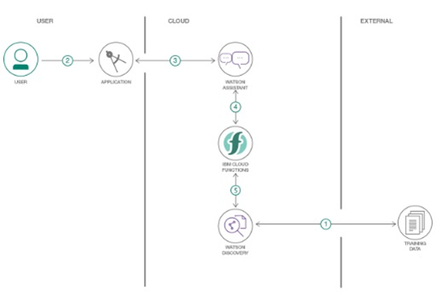

# Functional Requirements: -

* To create a chatbot using IBM Watson and Watson Discovery.
* The chatbot can answer simple questions.
* If the bot comes across technical questions it redirects questions to Watson Discovery.
* The Watson Discovery then answers questions with the help of pre-loaded owner’s manual.
* The project shall use the Smart Document Understanding feature of Watson Discovery to train it on what text in the owner’s manual is important and what is not.
* This will improve the answers returned from the queries.

# Technical Requirements: -

* Create a customer care dialog skill in Watson Assistant.
* Use Smart Document Understanding to build an enhanced Watson Discovery collection.
* Create an IBM Cloud Functions web action that allows Watson Assistant to post queries to Watson Discovery.
* Build a web application with integration to all these services & deploy the same on IBM Cloud Platform.

Software Requirements: -

* The chatbot should be able to respond quickly enough.
* The Watson Discovery should be able to handle traffic efficiently.
* The data should not get mixed up or there should be no data loss.
* The Watson Discovery should be trained efficiently with the help of Smart Document Understanding.
* IBM cloud functions should enable Watson Assistant to post queries to Watson Discovery.
* The chatbot should be able to work with any pc browser.

# Project Deliverables: -

The project should deliver a fully functional chatbot. The application should be able to answer basic questions like store locations, timings, etc. The technical or product related queries should be returned to Watson which will be enabled by IBM Cloud Functions to forward such queries to Watson Discovery. The Watson Discovery should answer through the pre-loaded user manual. The Watson Discovery should be trained with Smart Document Understanding to differentiate between the required and not-required text and respond to query accordingly.